KUBERNETES DEPLOYMENT STRATEGIES
Rolling Updates, Rollbacks and Replica Scaling

1. Objective
The objective of this experiment is to deploy an application on Kubernetes and demonstrate three core deployment operations: rolling updates, rollback to a previous revision, and horizontal scaling of application replicas. The experiment uses an NGINX Deployment with three initial replicas.

2. Tools and Technologies
- Kubernetes
- kubectl command-line tool
- Docker/OCI container image
- NGINX container image
- A Kubernetes cluster such as Minikube, Kind, Docker Desktop Kubernetes, or a cloud cluster

3. Deployment Configuration
Create a file named deployment.yaml with the following configuration:
apiVersion: apps/v1
kind: Deployment
metadata:
name: demo-web
spec:
replicas: 3
strategy:
type: RollingUpdate
rollingUpdate:
maxUnavailable: 1
maxSurge: 1
selector:
matchLabels:
app: demo-web
template:
metadata:
labels:
app: demo-web
spec:
containers:
- name: nginx
image: nginx:1.25
ports:
- containerPort: 80

4. Create the Initial Deployment
Apply the manifest and verify that three replicas are running:
kubectl apply -f deployment.yaml
kubectl get deployments
kubectl get pods
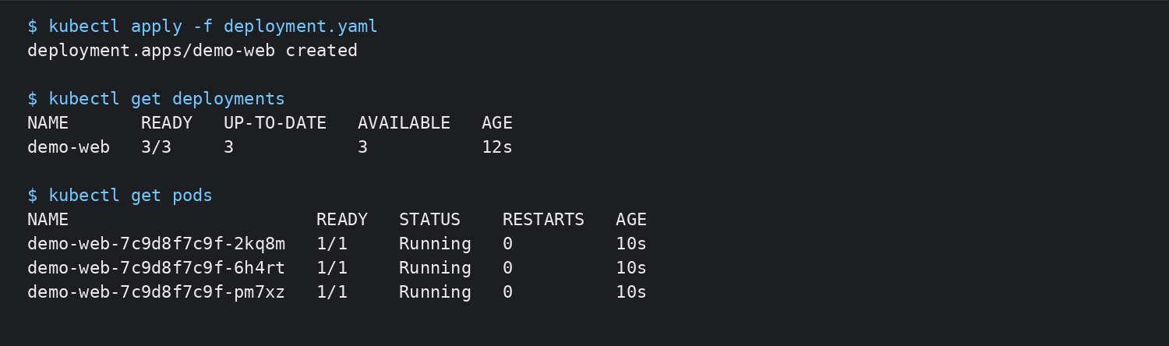
Figure 1. Initial Deployment and three running replicas (representative expected output).

5. Rolling Update
A rolling update replaces old Pods gradually instead of stopping all application replicas at once. This allows the application to remain available while the new version is being introduced.
kubectl set image deployment/demo-web nginx=nginx:1.27
kubectl rollout status deployment/demo-web
kubectl get pods -o wide
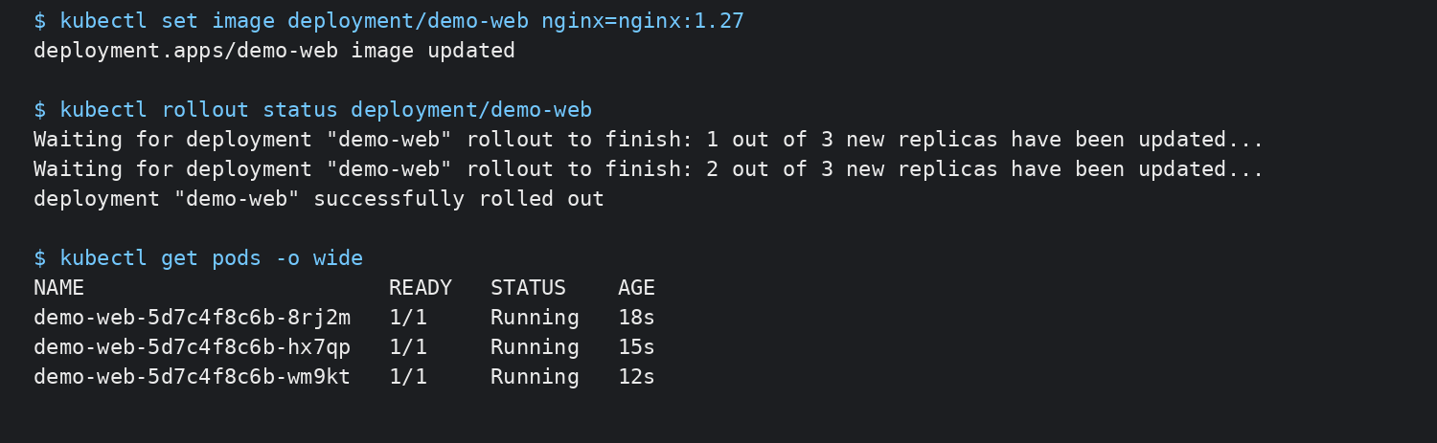
Figure 2. Rolling update from nginx:1.25 to nginx:1.27 (representative expected output).

6. Verify Rollout History
Kubernetes keeps rollout revisions for the Deployment. The history can be inspected before deciding whether a rollback is required.
kubectl rollout history deployment/demo-web
kubectl rollout history deployment/demo-web --revision=2
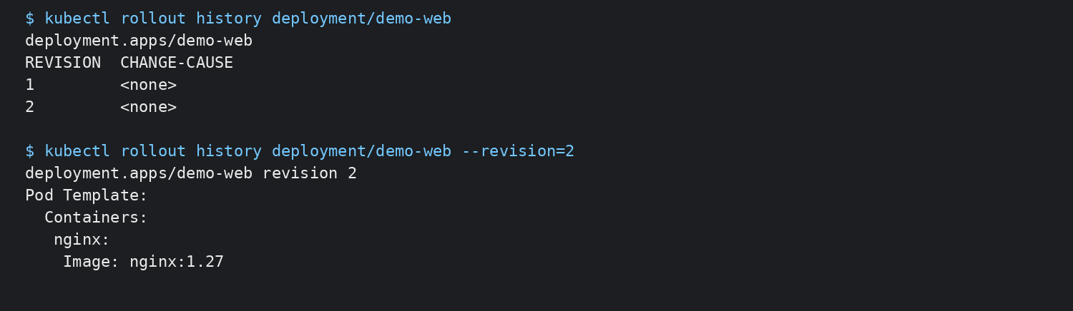
Figure 3. Deployment revision history (representative expected output).

7. Rollback to the Previous Version
If the new release causes an application problem, the Deployment can be returned to its previous revision. The following command starts a rollback and the status command confirms completion.
kubectl rollout undo deployment/demo-web
kubectl rollout status deployment/demo-web
kubectl get deployment demo-web
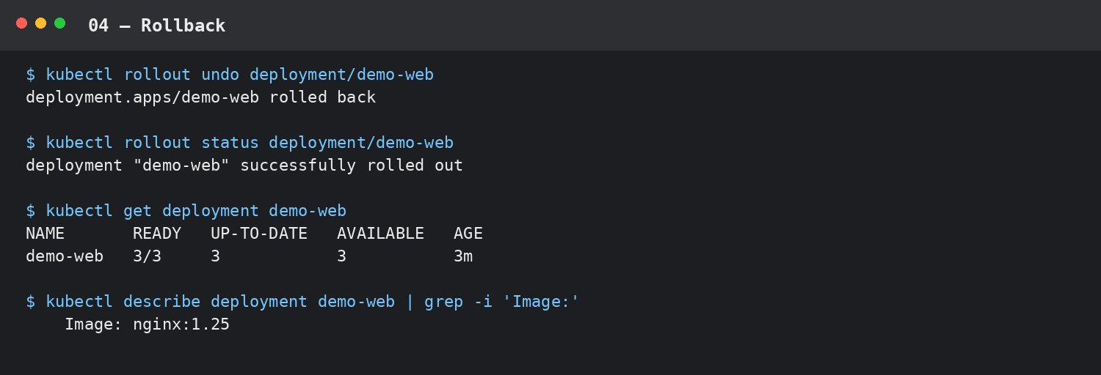
Figure 4. Rollback to the previous application image (representative expected output).

8. Scaling the Application
Kubernetes allows the number of Pods managed by a Deployment to be increased or decreased. The experiment first scales the application from 3 to 5 replicas and then scales it down to 2.
kubectl scale deployment/demo-web --replicas=5
kubectl get deployment demo-web
kubectl scale deployment/demo-web --replicas=2
kubectl get deployment demo-web
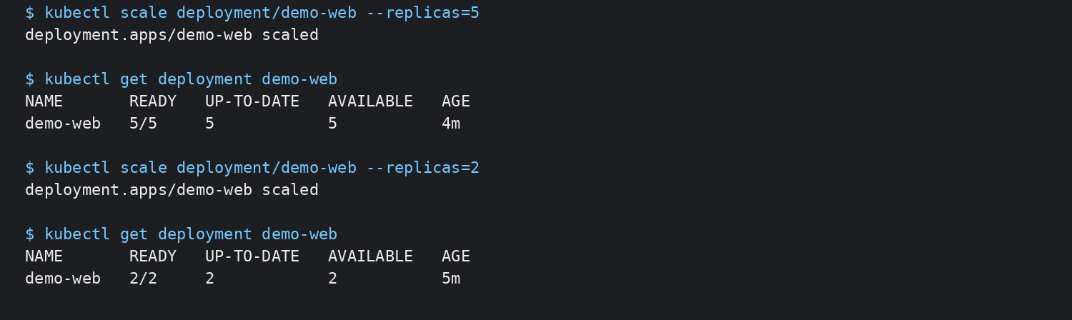
Figure 5. Scaling from 3 to 5 replicas and then down to 2 (representative expected output).

9. Useful Verification Commands
kubectl get deployment demo-web
kubectl get pods
kubectl describe deployment demo-web
kubectl rollout status deployment/demo-web
kubectl rollout history deployment/demo-web
kubectl get rs

10. Result
The Kubernetes Deployment was configured with a RollingUpdate strategy. The application was initially run with three replicas, updated from nginx:1.25 to nginx:1.27 using a rolling update, rolled back to the previous revision, and scaled to five and then two replicas. These operations demonstrate how Kubernetes manages application availability, version changes, recovery, and replica capacity.

11. Conclusion
Kubernetes Deployments provide controlled application releases through rolling updates and revision history. Rollbacks provide a recovery mechanism when a release needs to be reverted. Replica scaling allows the desired application capacity to be adjusted without changing the container image or application code.

